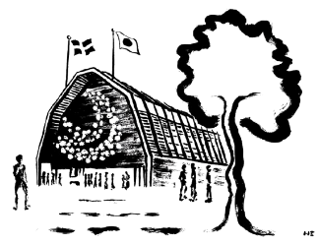

**Join Sweden to Pioneer the Possible:**

**Sweden’s National Day at Expo 2025 Osaka**

**Wednesday, 14th May 2025**

**PROGRAM DRAFT AS PER 6 MAY**

**National Day**

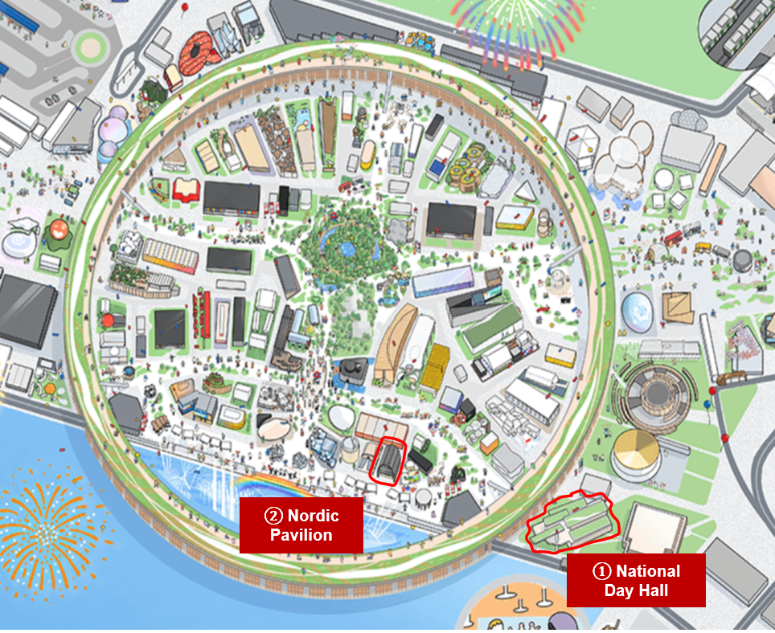

**West Gate**

**(arrival by car)**

**East Gate**

**(arrival by metro)**

**(metro statio**

**10.30 Arrival at National Day Hall**

**10.45 Take seat at reserved slots**

**11.00: Official National Day Ceremony**  
**Venue:** National Day Hall   
**Purpose:** To formally kick-off the celebrations of Sweden’s national day  
**Participants:** Official delegation, business delegation and visitors at expo  
**Moderator:** Representative from Expo organisation

- Hosting of the Swedish and Japanese flags

- Greeting from representative of the Government of Japan

- Greeting from His Majesty the King of Sweden

- New Swedish brand movie

- Music performance by Swedish artists and songwriters Malin Christin and Albin Nordqvist who will perform an acoustic set with songs they have written for Japanese artists accompanied by a moving slideshow presenting Sweden during all four seasons of a year

**11.40: End of National Day Ceremony**

**11.45: All business delegates up on stage for photo opportunity together with delegation leads**

**11.50: National Day Parade starts from National Day Hall**

**11.50: Guided walk with Business delegation to the Nordic pavilion**

**11.55: Business delegates start to arrive at the Nordic pavilion**

**12.00: Viewing of exhibition in Nordic pavilion** Delegates arriving asked to go through the exhibition and after that up to the top floor

**12.10: Networking lunch for business delegation*  
Venue:** Roof top terrace and large conference room  
**Purpose:** To network with the Swedish business delegation and participating Japanese guests  
**Audience:** Swedish business delegation and participating Japanese guests

**13.00: Experience the Expo – a curated walk for business delegation* *(Gathering outside of the Nordic pavilion. Have a look at your personal badge to see which group you belong to.)*  
Venue:** Different pavilions (tbc)  
**Purpose:** To explore highlights of the Expo  
**Audience:** Swedish business delegation and participating Japanese guests

**14.30: Registration for Business Summit opens**

*Special information: Invited speakers to Business Summit will get separate information regarding meeting time for preparation w. moderator*

**14.45 Be seated at dedicated seats at National Day Hall**

**14.55: Official delegation arrives at National Day Hall**

**15.00: Business Summit**

**“Join Sweden to Pioneer the Possible: Creating a resilient & future proof society – Actions for the next decade”   
Venue:** National Day Hall  
**Purpose:** This high-level summit, provides a platform for deepening strategic partnerships, exploring innovative solutions, and fostering bilateral ties between Swedish and Japanese stakeholders from industry, government, and academia.

**Participants:** Swedish official and business delegation and Japanese guests

**<SEE SEPARATE DOCUMENT>**

**18.00: Business Summit ends**

**18.05: Guided walk with delegates from National Day Hall to Nordic pavilion**

**18.15: Delegates arrive at the Evening Reception at Nordic pavilion**

**18.15: Evening Reception\***

*Special information: The evening reception will initially due to space limitation be divided into two different groups, blue and yellow, please have a look at your badge to see which group you belong to. You are free to explore the full pavilion after the welcome speeches and toast***Venue:** Nordic pavilion **Purpose:** To end the day’s celebration in a festive way and to network with invited Japanese stakeholders **Participants:** Swedish official and business delegation and invited Japanese stakeholders

**18.30: Welcome speeches and toast**- Welcome by Cecilia Ekholm, Commissioner General and Master of Ceremony

- Greeting and toast from HM The King Carl XVI Gustaf  
- Welcome by Johan Pehrson, Minister for Education  
- Jacob Wallenberg, Chair, Confederation of Swedish Enterprise  
- Short introduction to the menu by Head Chef Frida Ronge

**19.00: Music performance** produced by Swedish music tech company Teenage Engineering with Grammy award winning producers and musicians Patrik Berger and Pontus Winnberg supported by Swedish pop singer Esther

**20.00: Dessert**

**20.30: End of evening reception**

**20.30: Water Show in front of the pavilion**

**21.00: Drone Show in front of the pavilion**

**21.10: Guided walk to West/East Gate (Optional)**

**21.20: Metro leave for Grand Prince Hotel Osaka Bay**

**Pop-up stage Outer East**

**All day: Kid’s Lounge**

**- Purpose:** To showcase Sweden as a world leading country for gaming and to invite the general public to play Toca Boca games. The stage will also include a poster exhibition for the parents visiting describing Sweden’s long history of creating literature and culture for children based on play and the child’s perspective.

**- Audience:** The general public, focus children and families

**Pop-up stage West**

**All day: Music stage**

**- Purpose:** To showcase Sweden as a world leading country for music and music production by inviting the audience to create music together using music tech from Swedish company Teenage Engineering. In connection to the stage we will also show parts of the Swedish institute’s (SI) poster exhibition Swedish Music Moments.

- Audience: The general public

**Nordic pavilion**

**All day: Pioneer Prize posters and items**

**- Purpose:** To promote Sweden and Swedish companies as world leading within innovation by showcasing the eight Swedish SME companies competing in SI’s award campaign Pioneer Prize through videos, posters and items.

**- Audience:** The Swedish official and business delegations as well as invited Japanese guests